Name: Roshini Joga

SJSU ID: 018221736

**Question:**

**Configure two VMs, VM1 and VM2 either on your own hardware, or in a cloud environment. Configure Ansible to deploy a webserver on *VM1* and *VM2* on port 8080 with a web page that is accessible from a web browser, and displays the message: “Hello World from SJSU-X” where X is 1 or 2 depending on which web server instance, VM1 or VM2.**

**Include in the Ansible playbook, plays to deploy and un-deploy the webserver resources**

Github: <https://github.com/roshini-joga/Ansible/tree/master>

**Created 2 VM’s on Google Cloud Platform (GCP)**

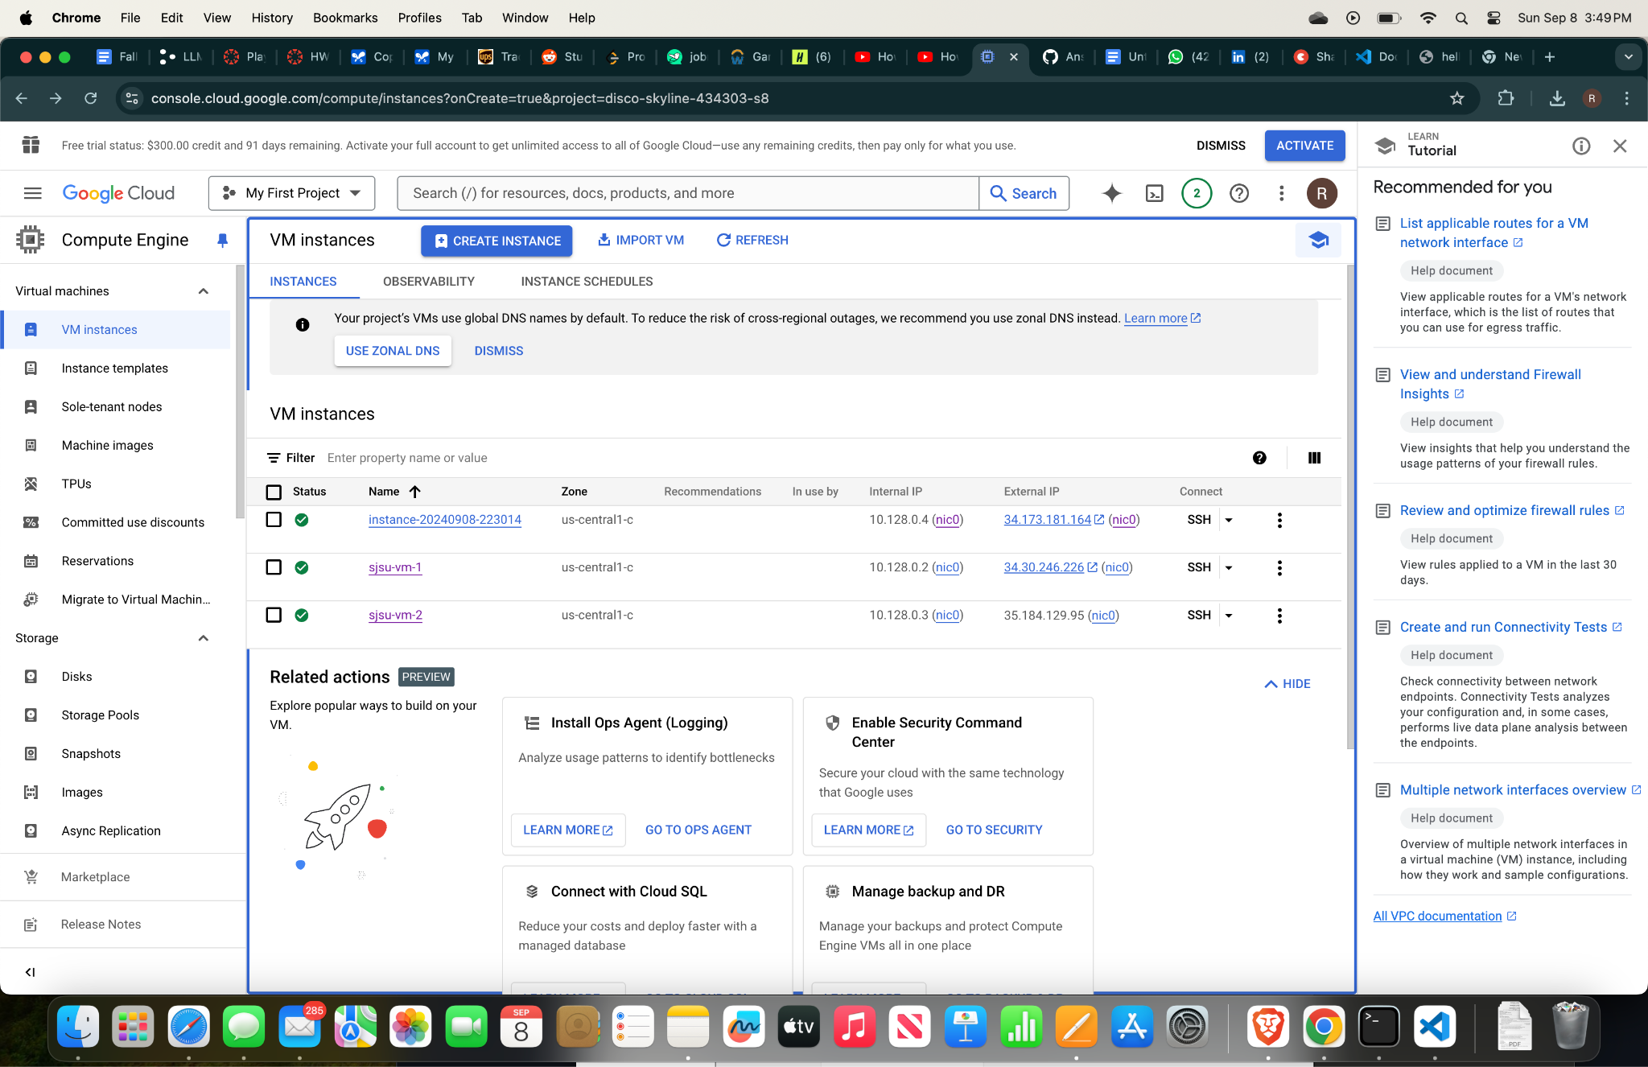

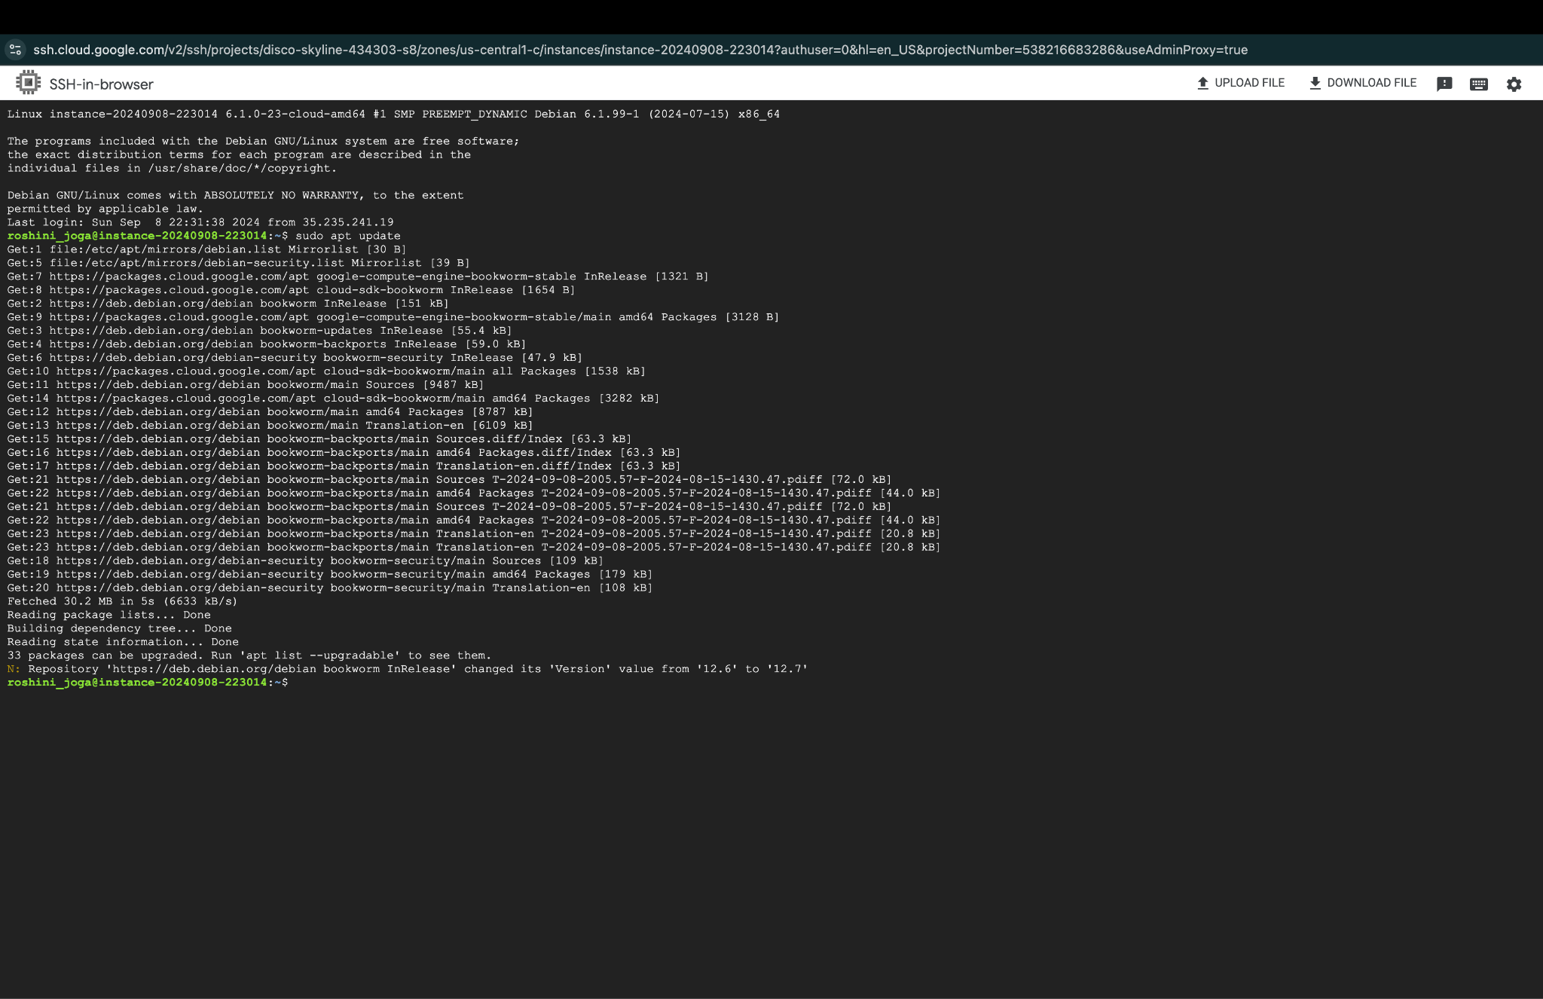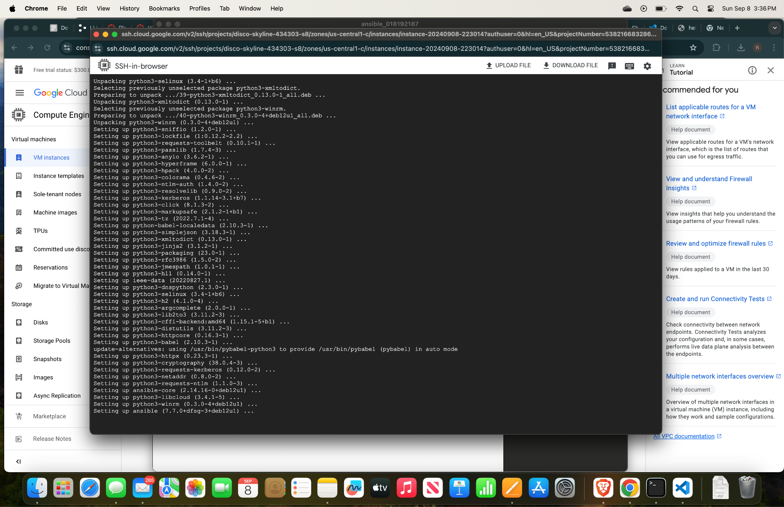

**Adding IPs of host files create an inventory file inventory.ini**

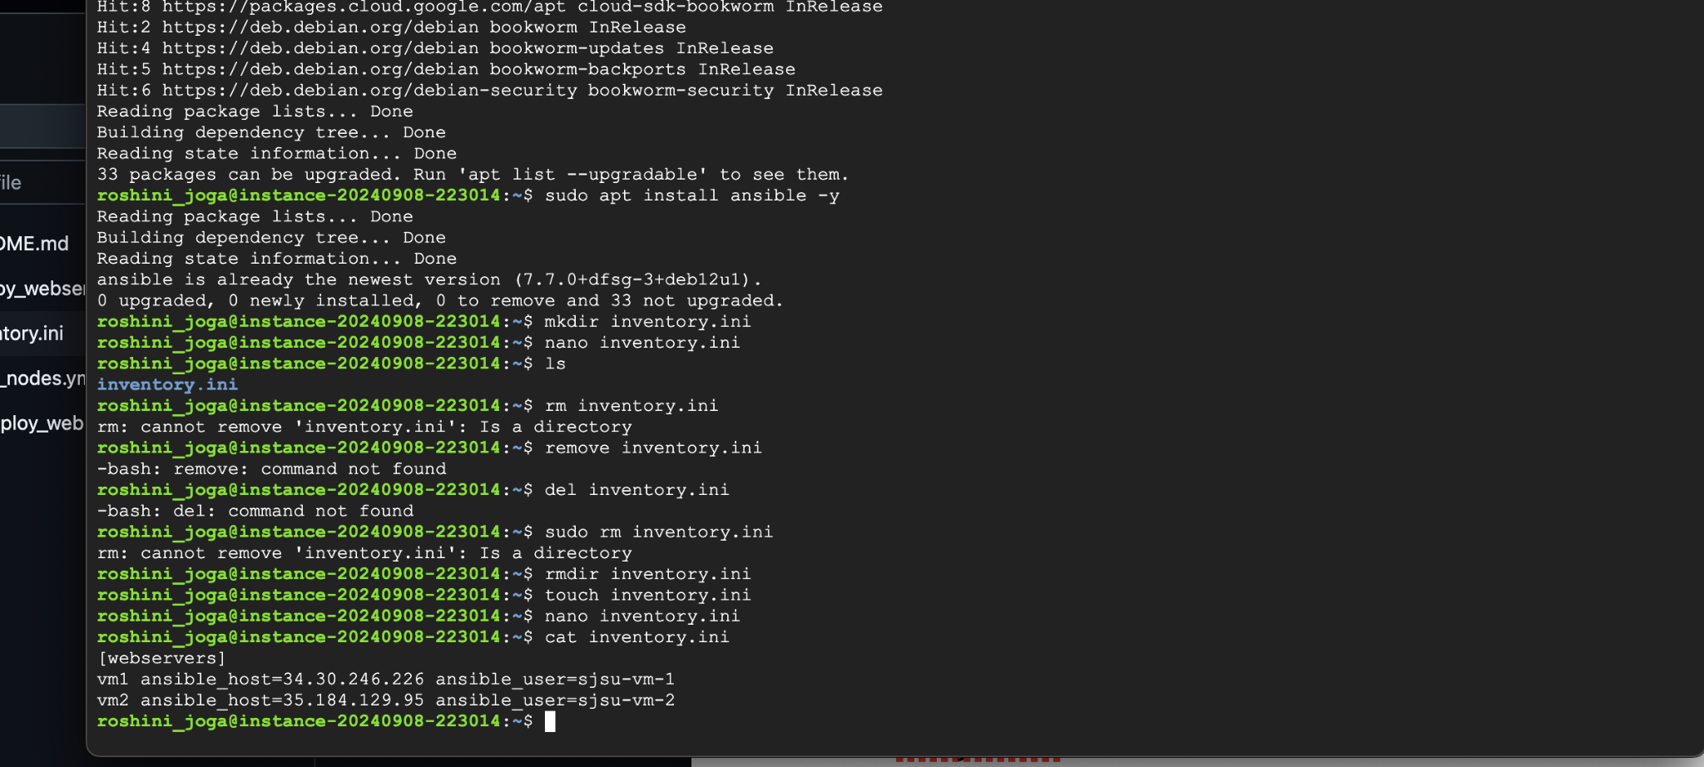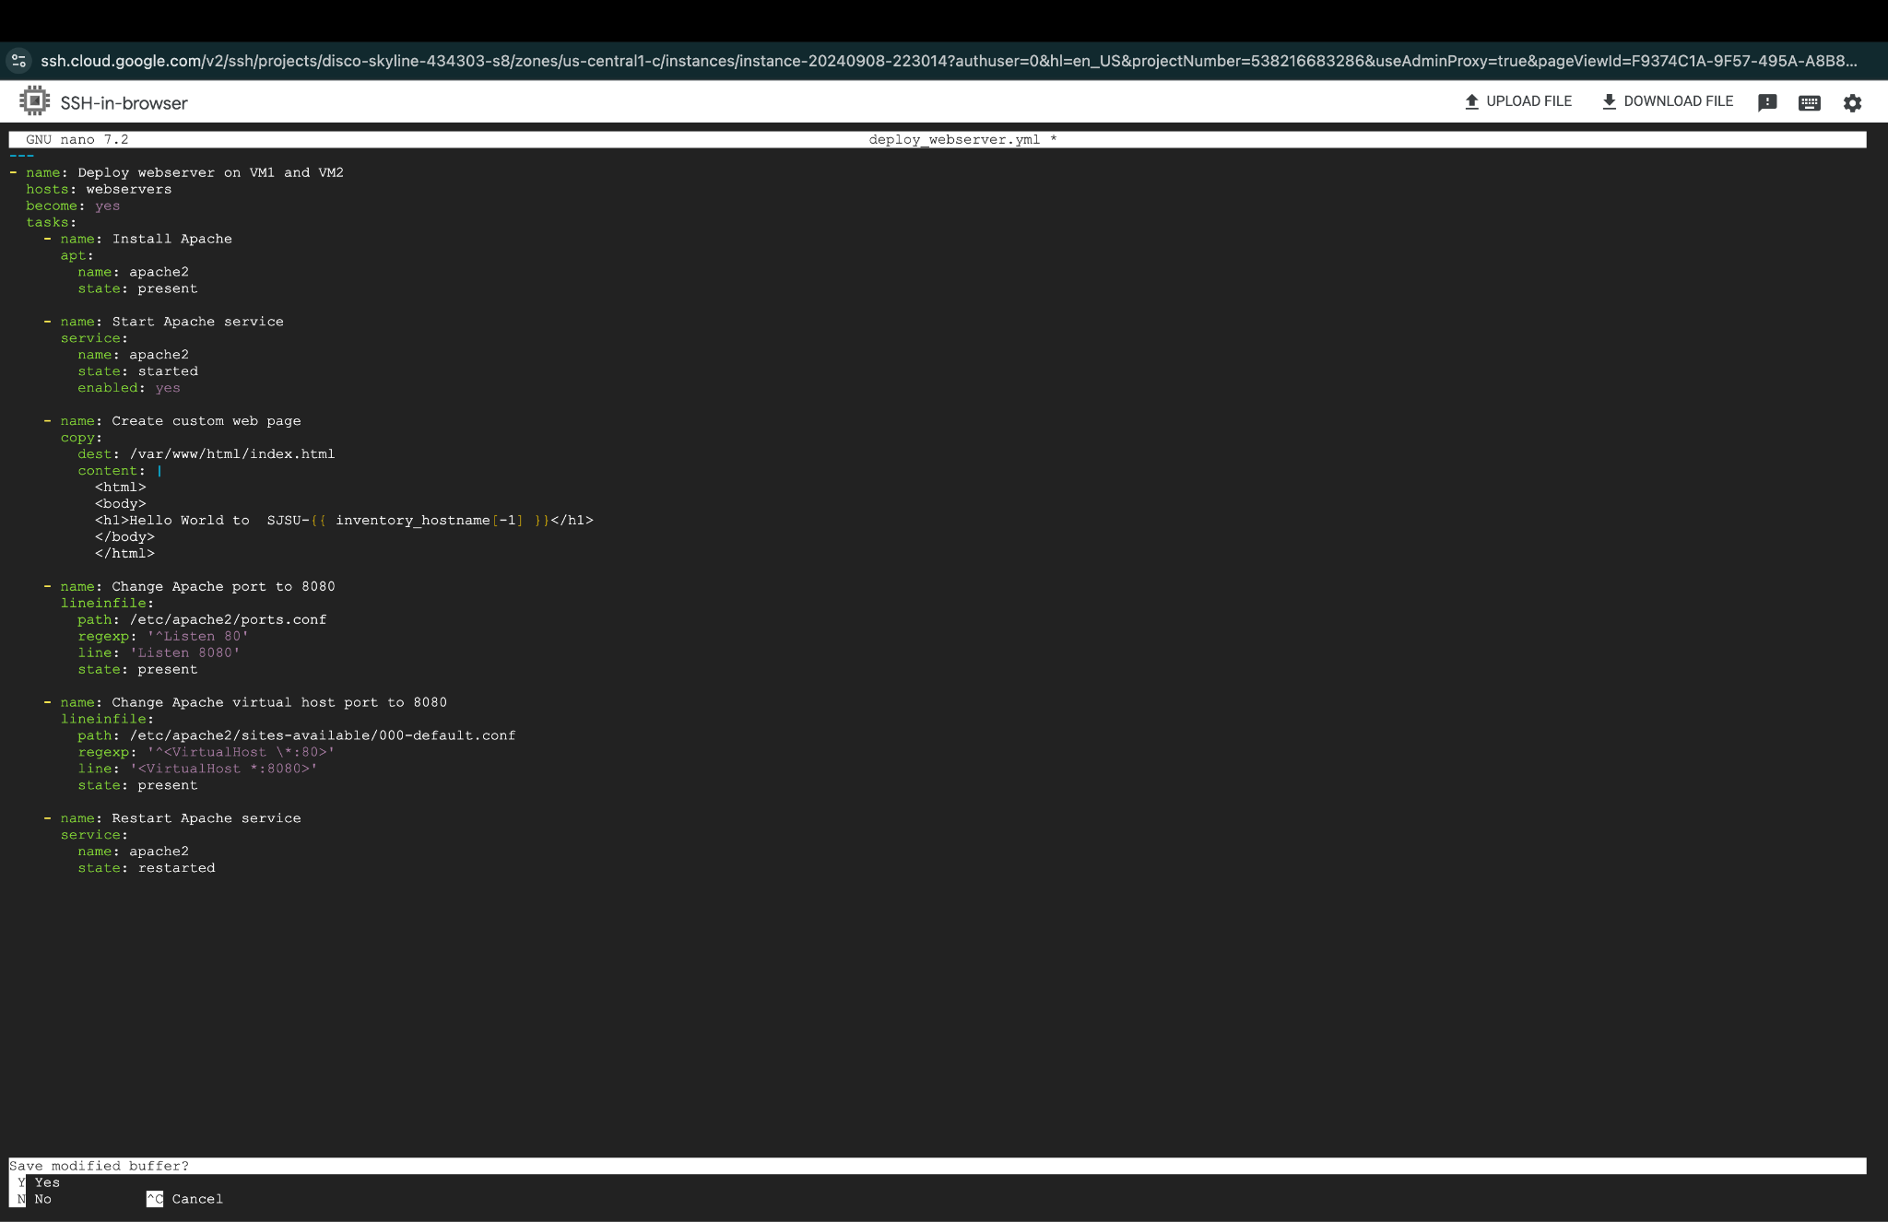

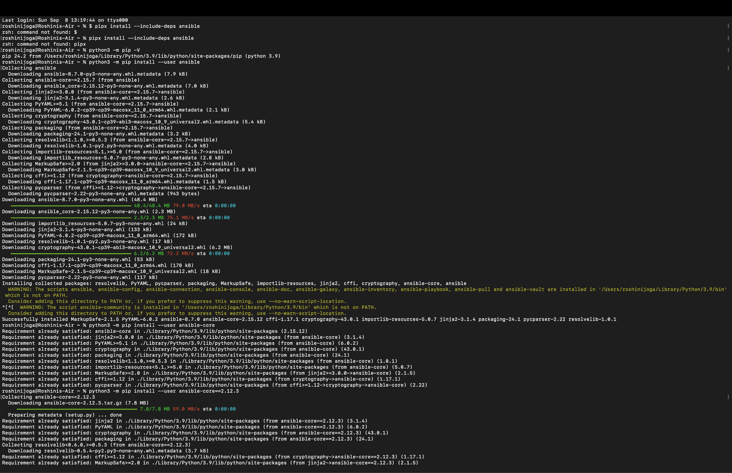

**Pinging the VM’s to validate the connection using ansible.**

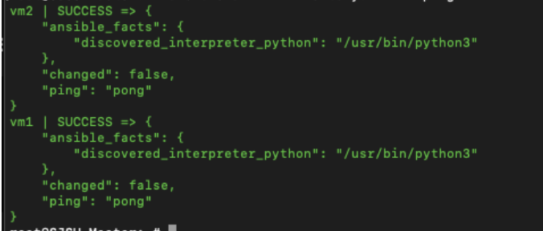

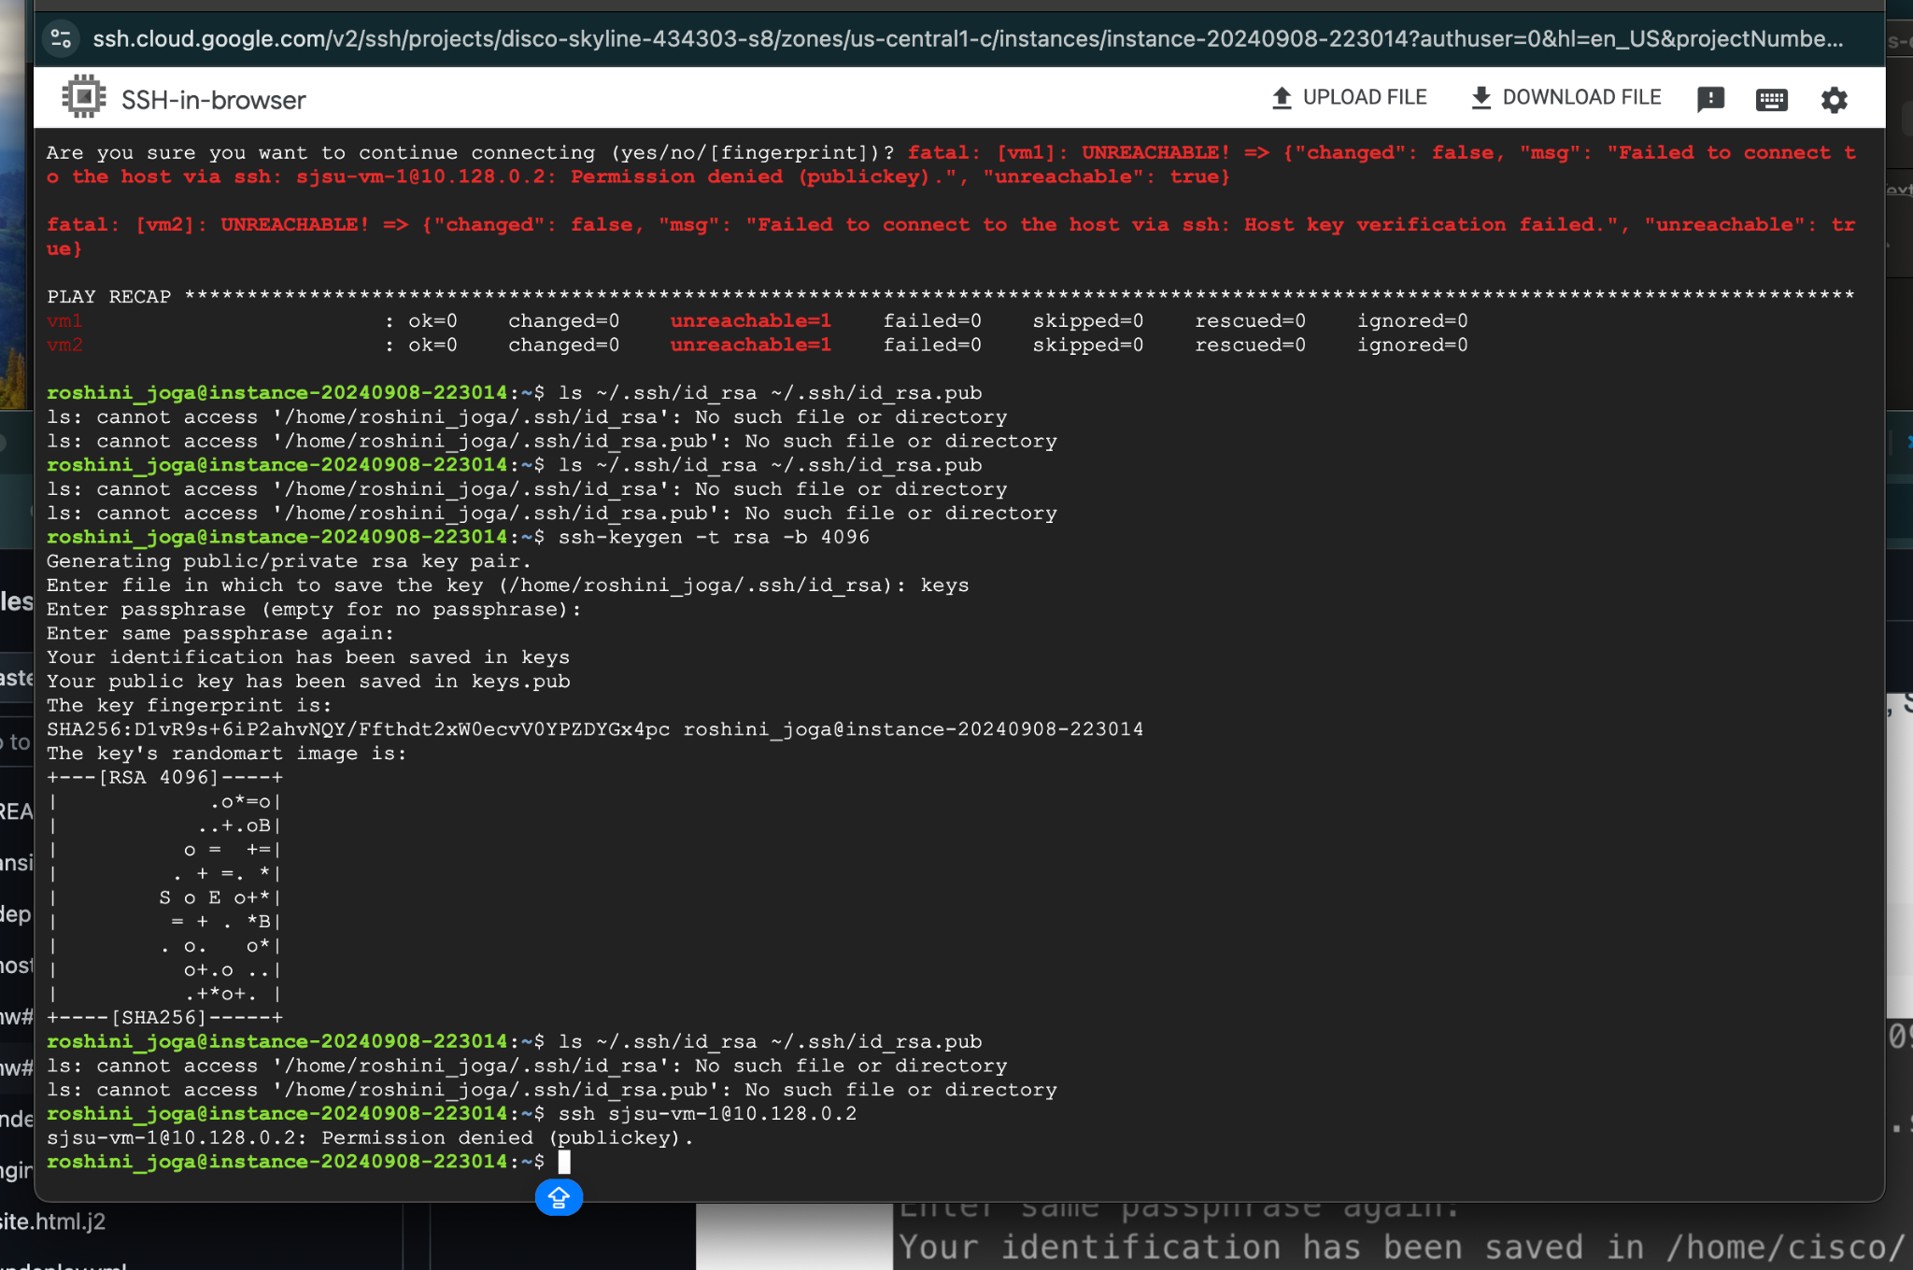

**ansible-playbook -i inventory.ini deploy_webserver.yml**

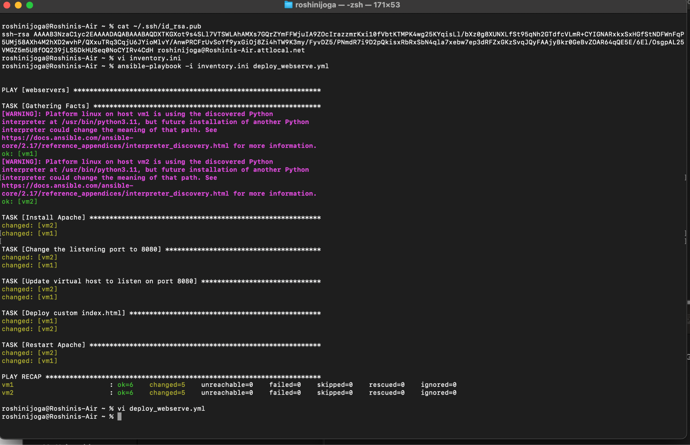

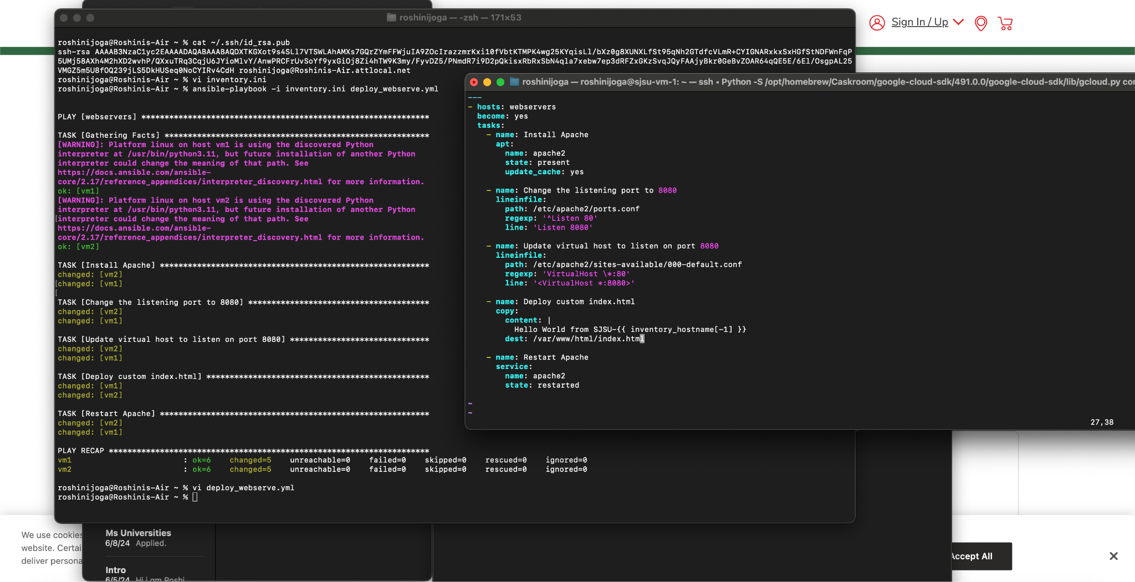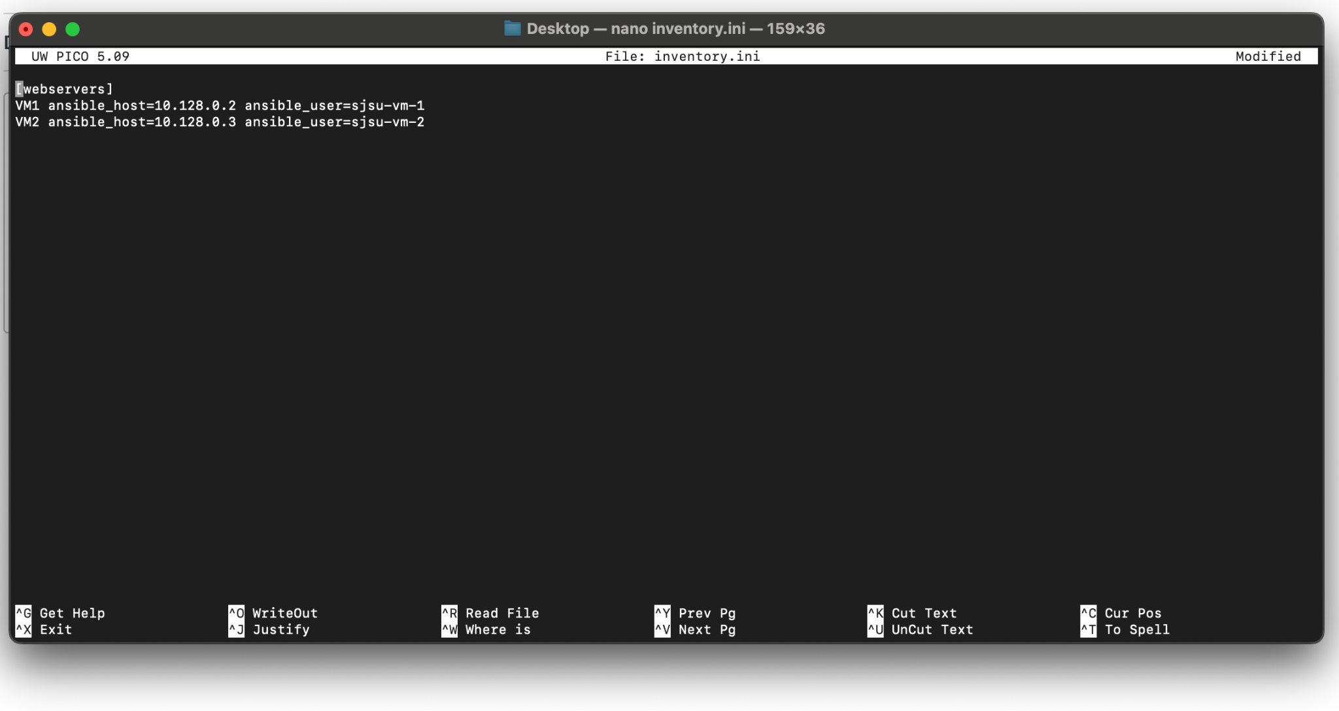

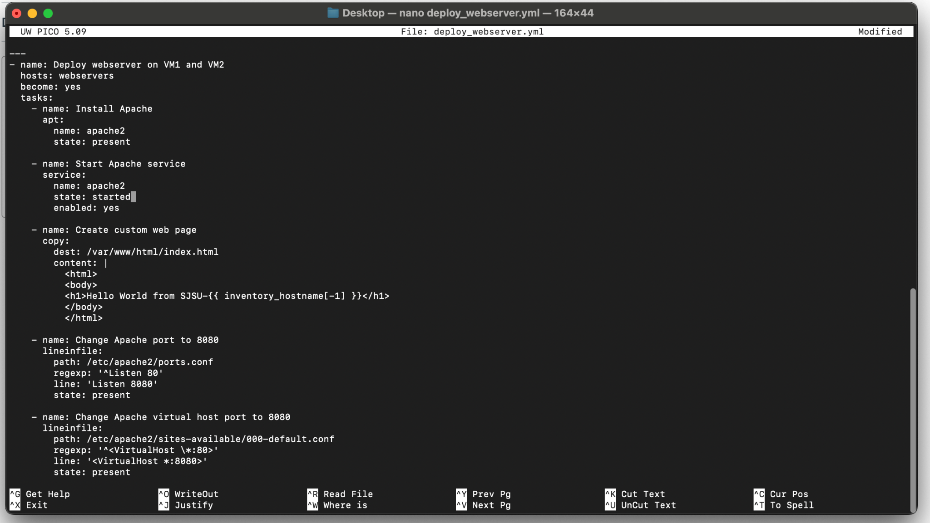

Deploying servers:

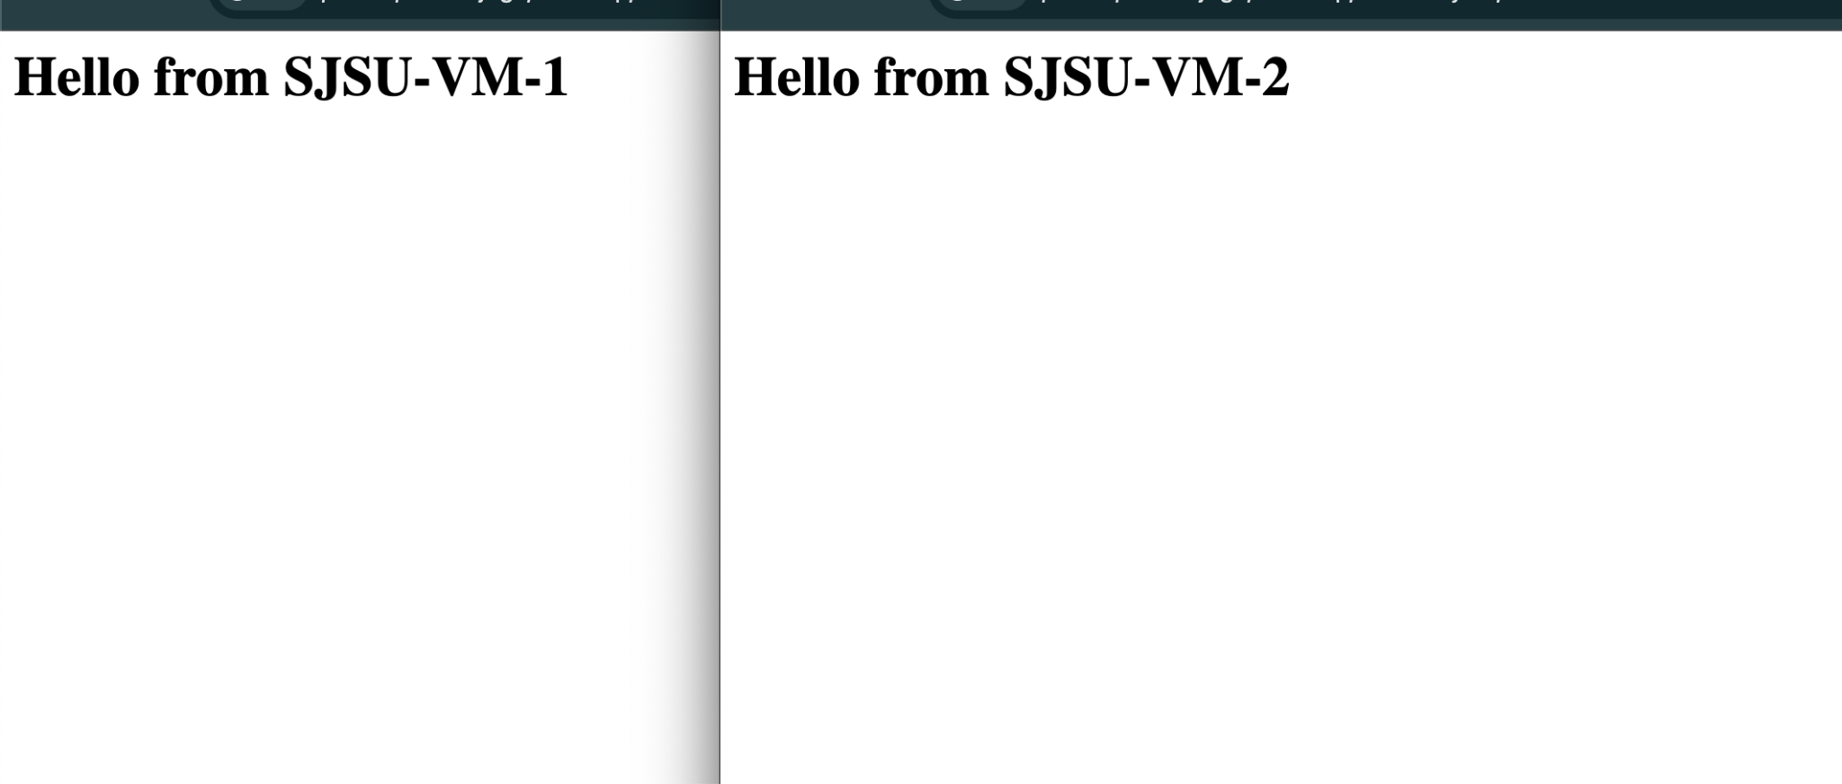

Undeploying the servers:

